UAT Plan

for

RepTracker sprint 0.01

Index

1. Scope 3

1.1. Objectives and business requirements 3

1.2. Scope 3

2. Testing team 4

3. Environmental requirements 5

3.1. Hardware requirements 5

3.2. Software requirements 5

4. Test Scripts 1

# Scope

## Objectives and business requirements

In this section, outline the business requirements. In other words:

We well be testing the UI of the landing page of the RepTracker

## Scope

* Testing the UI of the landing page only
* Ensuring the responsiveness of the UI is working

## System Diagrams

Storyboard:

Story board is missing the user documentation page

Structure chart:

(first half)

This storyboard is missing the user documentation page

(second half)

Dataflow:

Data flow is missing user documentation page

Context diagram:

Flowchart:

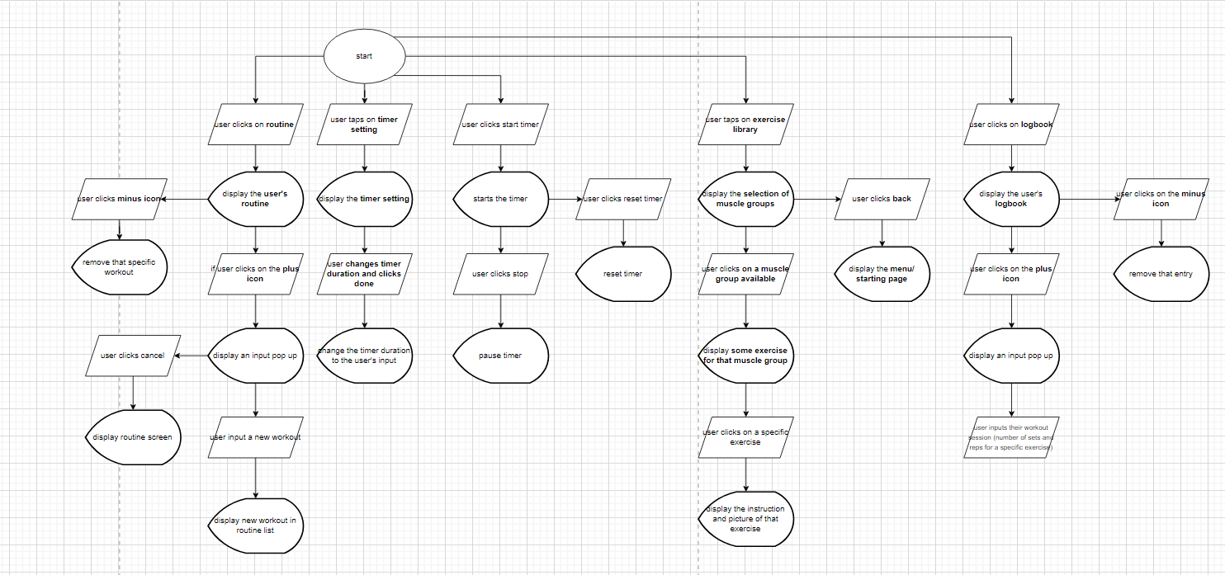

Flowchart is missing user documentation page

*Example:*

*Storyboards, wireframes, flowcharts, schematics, pictorials, mood-boards, etc.*

# Testing team

In this section, list out members of your QA team and what their roles will be during UAT.

|  |  |
| --- | --- |
| **Name** | **Responsibilities** |
| Sean Perpignani | Testing the UI of RepTracker |
|  |  |
|  |  |
|  |  |
|  |  |

# Environmental requirements

## Hardware requirements

iPhone 6 or newer

Samsung galaxy s6 or newer

Window PC

## Software requirements

If any extra software or dependencies must be downloaded and installed, list them here.

Google chrome (PC)

Google (android)

Safari (phone)

## Network requirements

Have access to internet

# Test Scripts

This section is more important than it seems—it is crucial that both the QA team and the testers know what features must be tested, especially if you’re testing a lot at once.

|  |  |  |  |  |
| --- | --- | --- | --- | --- |
| **Test** | **Describe the feature being tested** | **Describe the user input or test data** | **Describe the pass criteria** |  |
| 1 | Page displays the correct UI | User needs to first navigate to <https://tempehs.github.io/2024SDD-Linh-RepTracker/> which is accessible through GitHub (on pc) | Page loads a display similar to the one above | Tester name: Sean Perpignani   |  |  | | --- | --- | | X | PASS | |  | FAIL |   Observations:  The page loads as it should |
| 2 | page is responsive to screen size | User needs to first navigate to <https://tempehs.github.io/2024SDD-Linh-RepTracker/> which is accessible through GitHub (on a phone) | Page loads a display similar to the one above | Tester name:   |  |  | | --- | --- | | X | PASS | |  | FAIL |   Observations:  The page loads as it should |

Tip: Write step-by-step, detailed but concise instructions on how to test the feature.